**Twitter Sentimental Analysis**

We have downloaded the data for hashtag “#F1visa” because it is very trending now a days. We downloaded data on 2 days, one after a certain day when the new guideline came and other when the guideline was reverted by the DHS and ICE. After that we studied the change in sentiments over the period.

**Below are the sentiment plots for day 1 (7/10/2020):**

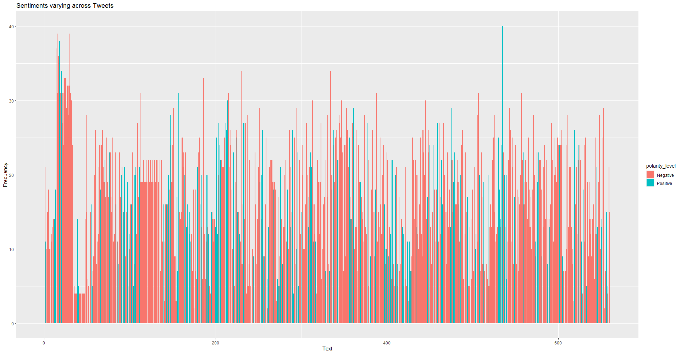

Plot1

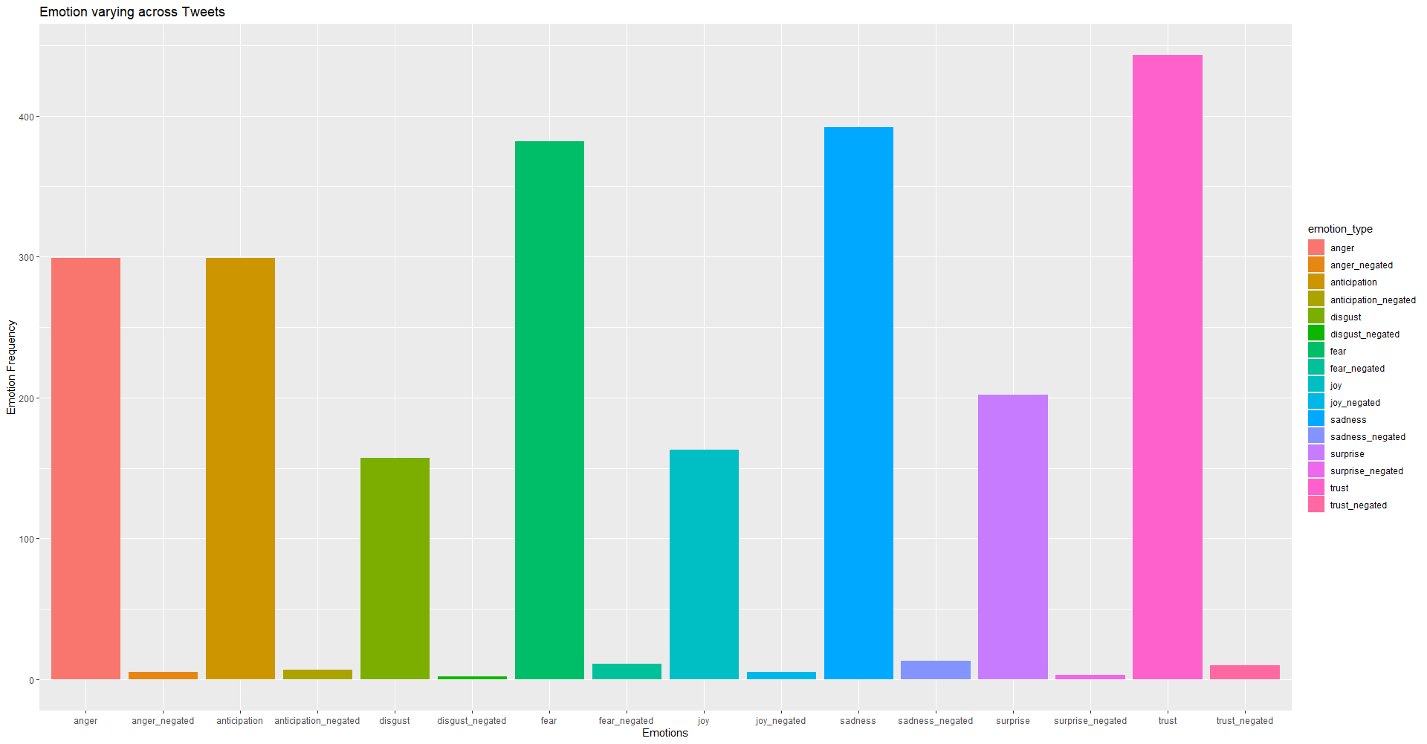

Plot2

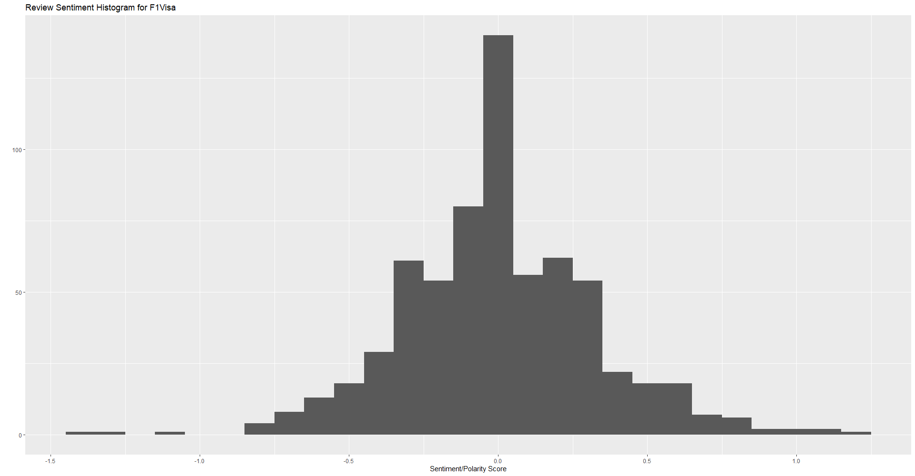

Plot 3

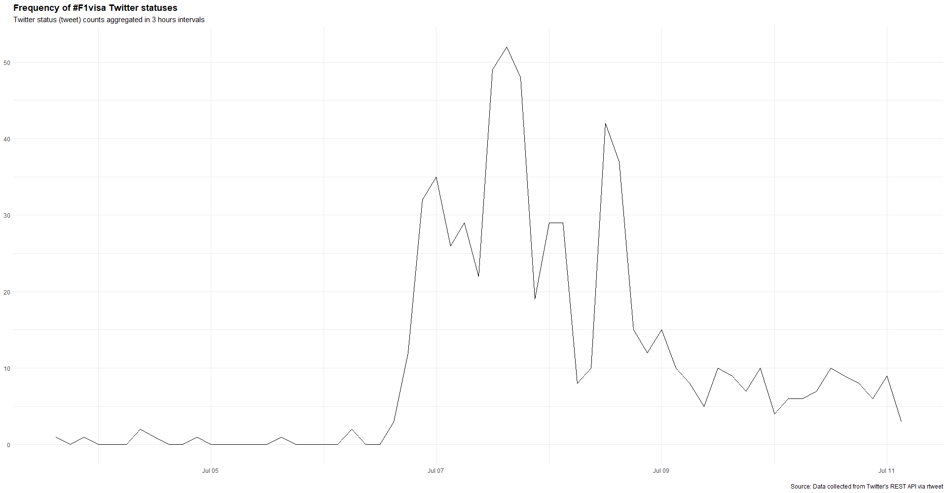

Plot 4

From plot 4, As we can see there is a spike in tweets containing “#F1visa” because the new guidelines came for international students on July 6th. After that there are many tweets for couple of days and then there is a little decline in number of tweets.

Also, from plot 1, we can notice that there are many negative sentiments about the topic. Therefore, we can infer that people have negative sentiments of negative feeling on the new guidelines.

From plot 3, we can see different emotions of overall set that we got on the day. And there we see that negative emotions are more.

**Sentiment plots for day 2 (7/15/2020):**

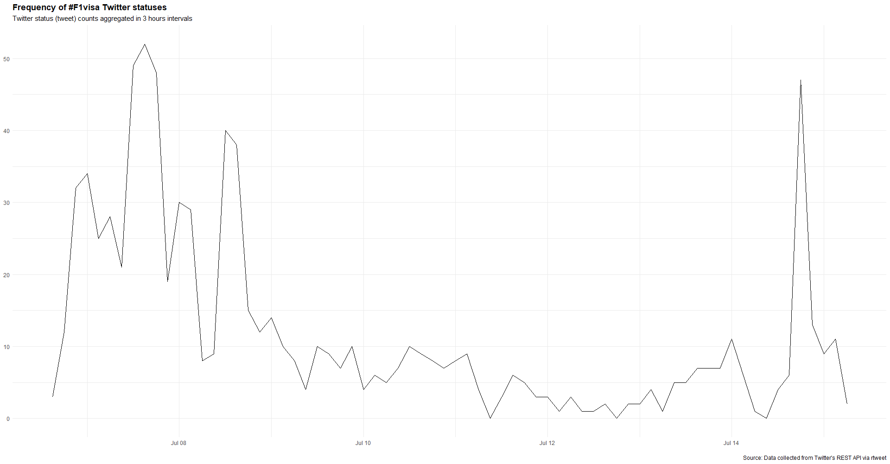

Plot1

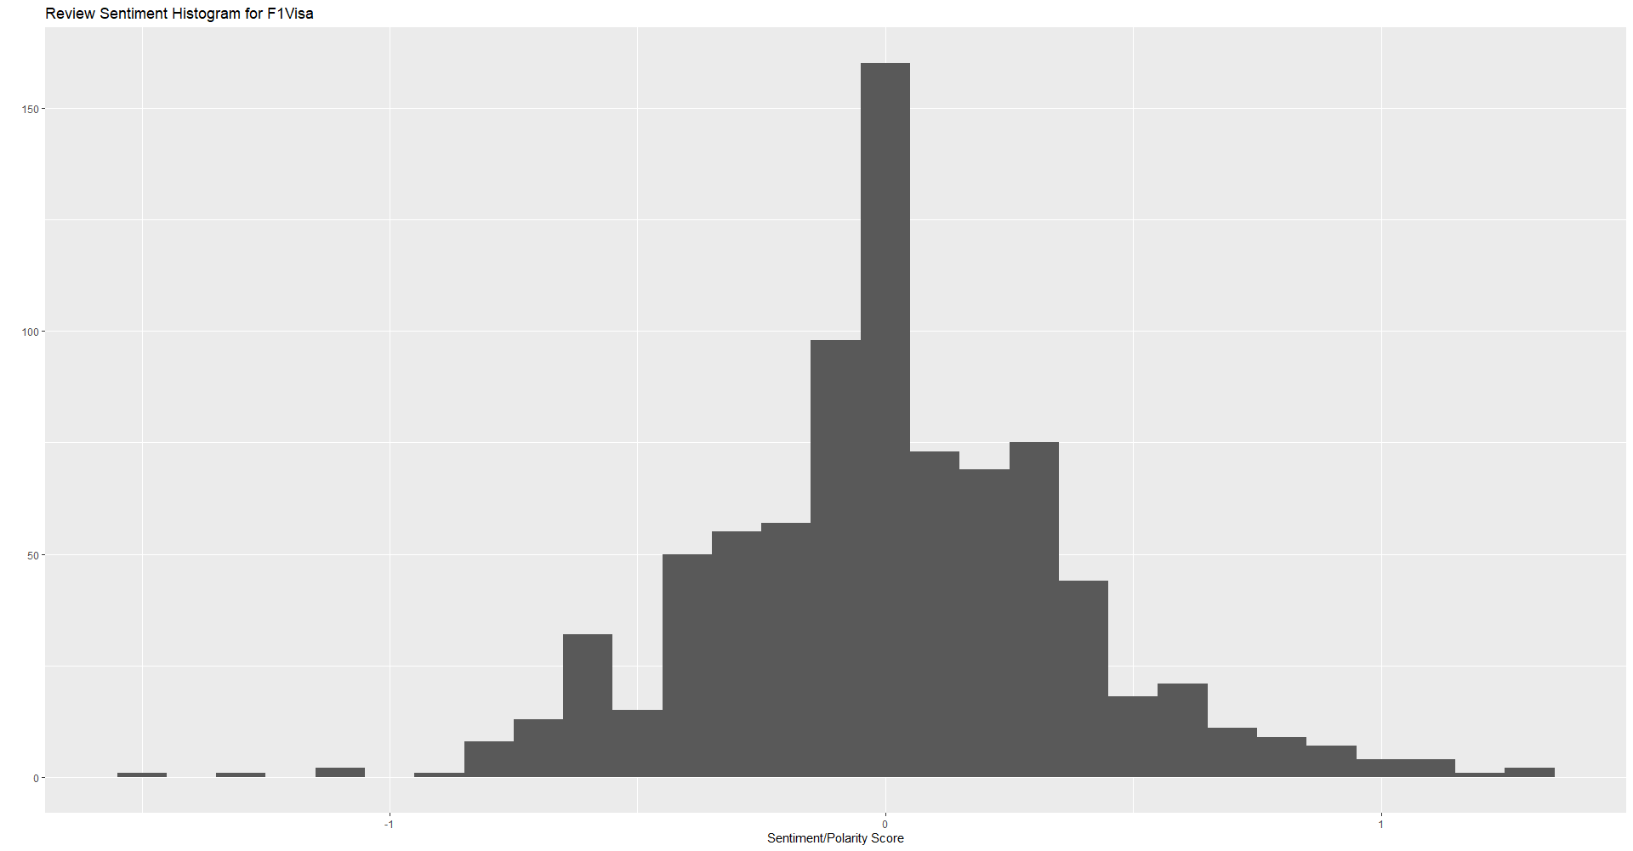

Plot2

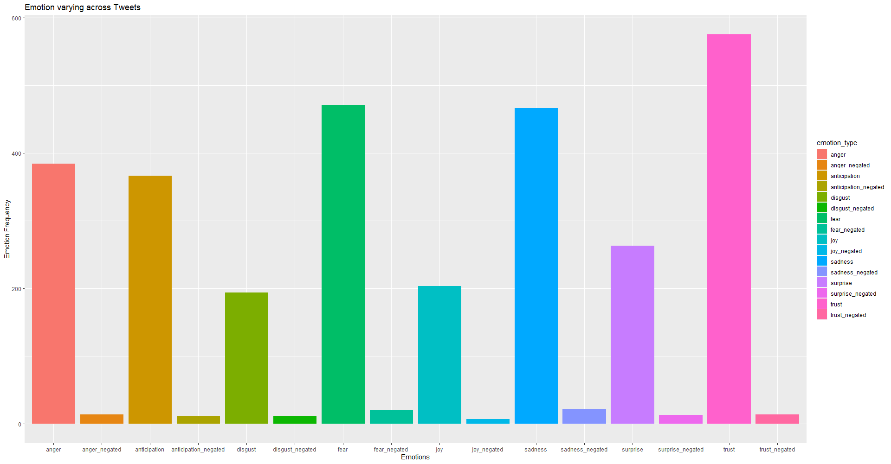

Plot3

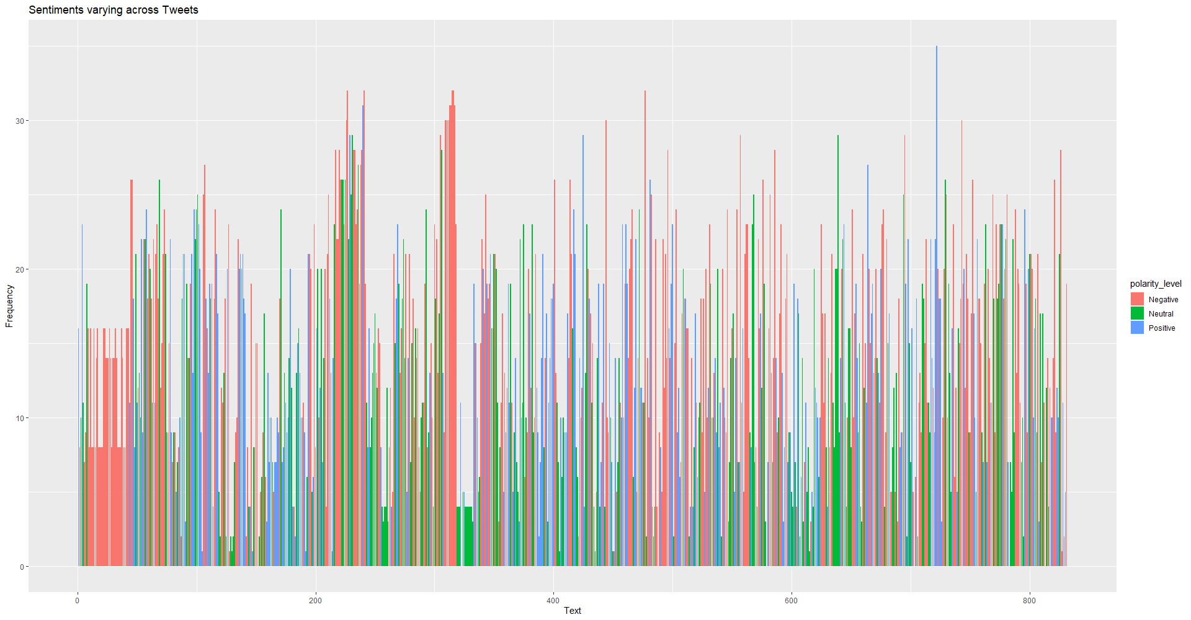

Plot4

From plot 3 and 4, after the guideline was reverted by ICE and DHS, there were more positive tweets about the topic for which we were doing data analysis.

From plot 1, we can see that there were fewer number of tweets on previous day but suddenly on July 14th the tweet count increased after the new guideline was reverted. This shows that tweet counts are directly proportional to the incident related to the topic.

One interesting finding from both the days tweet collection is that sentiment polarity was somewhat a bell curve or normal distribution.

Hence, we can conclude that twitter population was having positive response on the reversal of the guideline for international students.